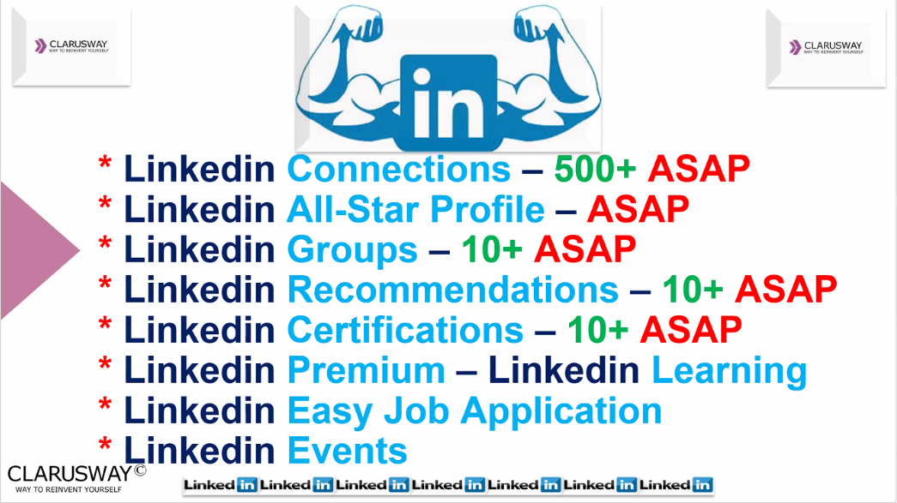

**How to Achieve All-Star Status on LinkedIn**

According to LinkedIn, All-Star profiles are **40X more likely to receive job opportunities**.

## **The 8 essential elements you need for LinkedIn All-Star status**

### **#1 - LinkedIn Profile Picture**

Having a high-quality profile picture is crucial to getting All-Star status on your LinkedIn profile. In fact, LinkedIn users who include a photo receive **21X more profile views** than users without one.

Your picture is your first impression. The researchers found that it only takes 33 milliseconds for someone to make a first impression of you when they look at your profile picture.

This impression includes evaluating your status, attractiveness, and trust.

The best way to build that attraction and trust is by having a brightly lit picture that clearly shows your face and has a positive energy to it.

### **#2 - Headline**

Your goal with your headline is to appear in more searches and stand out from everyone else who appears in those searches.

Here’s an example:

5+ years in Marketing | Recognized as Top 10 in my company | Helping businesses grow their social media to increase sales

### **#3 - Industry & Location**

This step is probably one of the easiest ways to get closer to All-Star status. When editing your profile, make sure to enter your country, zip code, and your industry.

These areas tell the recruiters where you reside and what industry you’re in. A lot of recruiters will search for job candidates on LinkedIn using the industry and location settings, so if you leave this blank, you’ll be left out of the results.

### **#4 - Experience**

For the experience section you will need to include your most current position plus two prior positions.

According to Forbes, LinkedIn members with current positions are **discovered 16X more in recruiter searches** and their profile views increase up to 29X. The bullet points here, just like on your resume, should be achievement-based and targeted towards your desired job or field.

### **#5 - Skills**

To achieve All-Star status, you need to include at least 5 skills in your skills section. In fact, LinkedIn reports that users with five skills or more are **contacted up to 33X more by recruiters.**

Adding skills to your LinkedIn profile may sound easy, but you want to be smart about the skills you choose. Of course, you’ll want to include skills that you’re good at, but it’s also important to add skills related to the keywords employers are using to find candidates.

An easy way to find which keywords go with your role is simply by looking through 5-10 job postings on LinkedIn. After a while, you’ll start noticing certain words popping up over and over again that you can use for your skills section.

### **#6 - Summary**

Out of all the sections in this post, this might be the hardest section to nail down. It may take you some time and energy to craft a compelling summary, but this is your opportunity to market yourself to employers.

I personally recommend a three-part Summary:

1. **An opening statement** that summarizes your work experience and your most impressive and relevant skills. Make sure to include relevant keywords here to increase your chance of appearing in recruiter’s searches.
2. **A few bullet points** focused on your achievements, rather than your duties. You can quantify your achievements with numbers and even start your bullets with an action or “success verb” to prove your value.
3. **A closing statement** about what types of opportunities get you excited and what kind of roles someone should get in touch with you for.

You can also include a letter of recommendation, a testimonial from a coworker/ boss, or any additional items that back up your job title.

### **#7 - Education**

The biggest benefit of adding this section is that it gives you an opportunity to connect or be found by fellow alumni since you will have built-in connections. This section is also especially important if you’re a recent graduate or a student.

### **#8 - Connections**

Adding Links: **While you can only send 100 connection requests per week** on the LinkedIn platform, you can send way more than that IF you know their email address.

To reach All-Star status you need at least 50 connections. You can connect with others by sending them an invitation or by accepting their invitations. You can also jump start your connections by allowing LinkedIn to match you up with people from your email address book.

Another way to start is simply by using the search feature to find companies you used to work at and connecting with your ex-coworkers. Establishing connections and interacting is a core part of LinkedIn and the platform will reward you in search results if you have more connections.

**Getting to LinkedIn All-Star Status**

I know this may look like a lot of work to you, but the good news is that **only 51% of LinkedIn users have fully completed profiles** so this is an incredibly easy way to stand out.

**LinkedIn Privacy and Security Settings**

**Turkish Link:** LinkedIn'de Güvenlik ve Gizlilik Ayarları Nasıl Yapılır?

<https://www.youtube.com/watch?v=eb9Hb-spBHc>

**English Link:** LinkedIn Privacy and Security Settings

<https://www.youtube.com/watch?v=fT2wtp0-xAQ>

**Adım Adım Linkedin Hesabı Oluşturma**

**Turkish Link:**

<https://www.kalitelibacklink.com/adim-adim-linkedin-profili-olusturma/>

**English Links:**

<https://www.opencolleges.edu.au/blog/2020/05/25/beginners-guide-to-linkedin/>

<https://www.linkedin.com/pulse/linkedin-beginner-all-star-8-easy-steps-clifford-wessel/>